Step1 :google search 🡪selenium webdriver jar download

[Downloads | Selenium](https://www.selenium.dev/downloads/)

[https://www.selenium.dev › downloads](https://www.selenium.dev/downloads/)

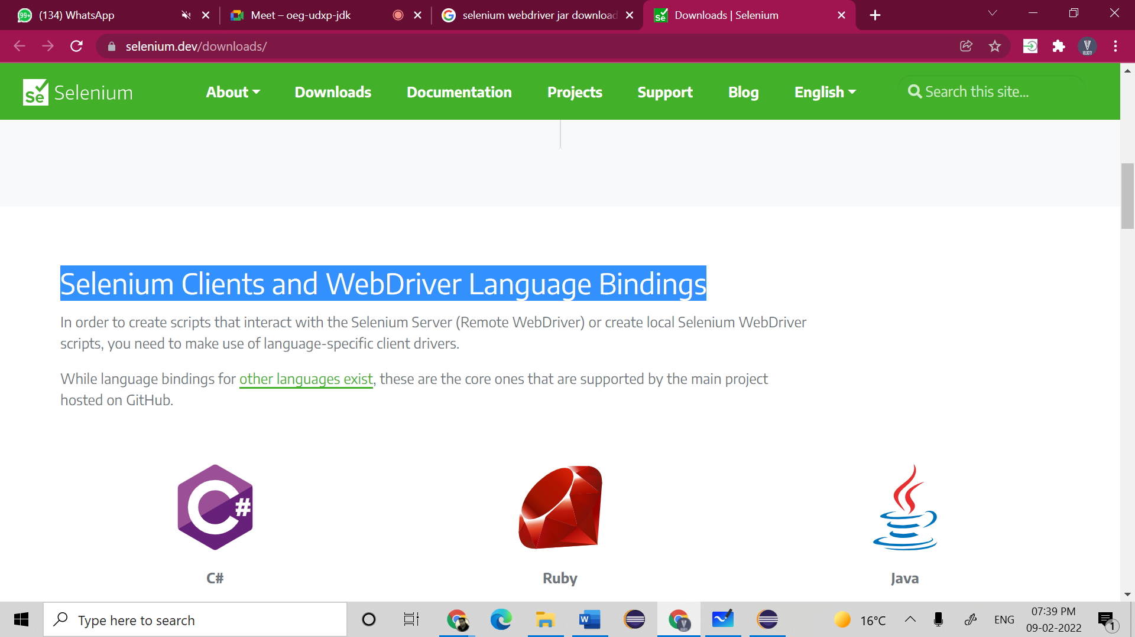

Click on java stable version

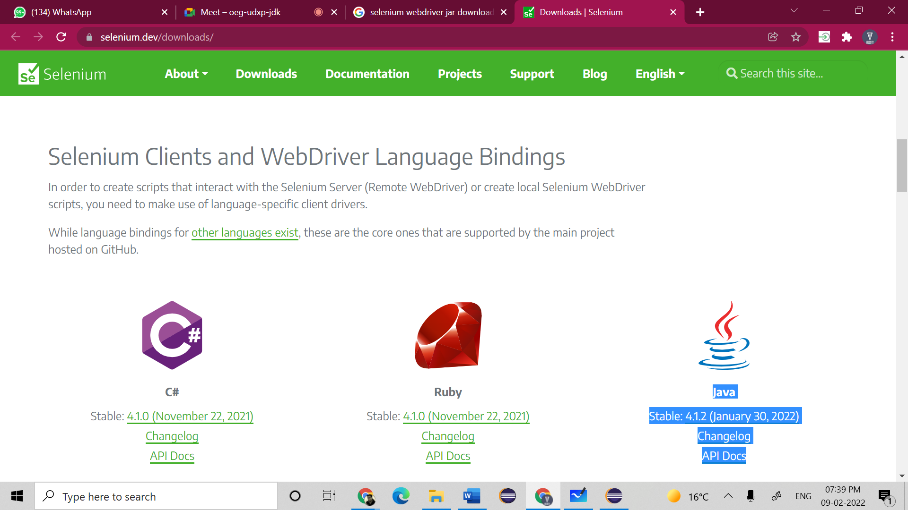

Zip files will be downloaded and extract that folder and place at your desired location.

Keep all jars at one place.

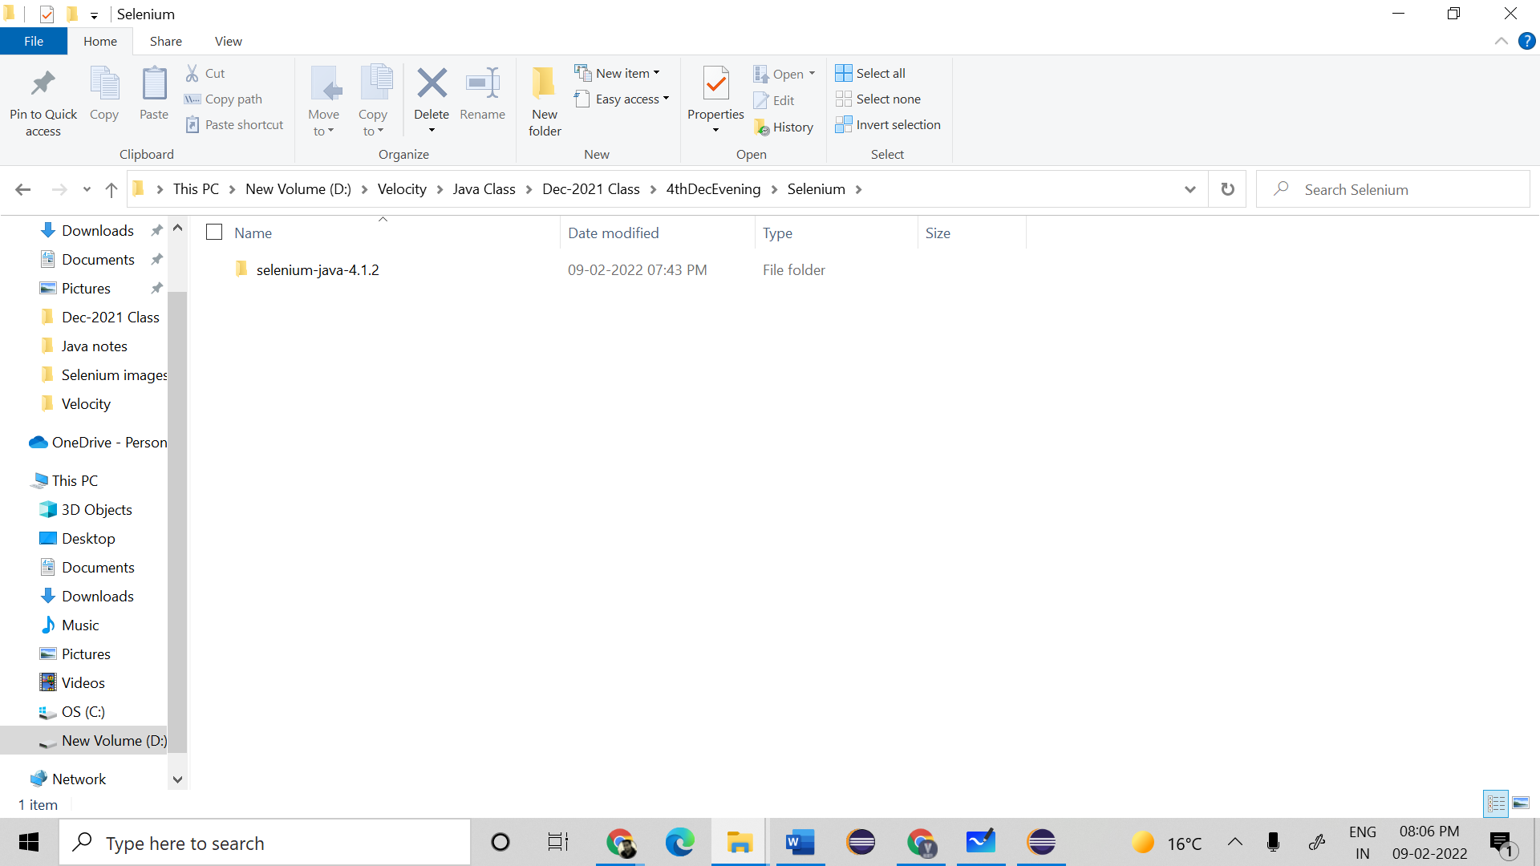

Check your chrome browser version

Browser settings🡪 about chrome🡪 version(97……)

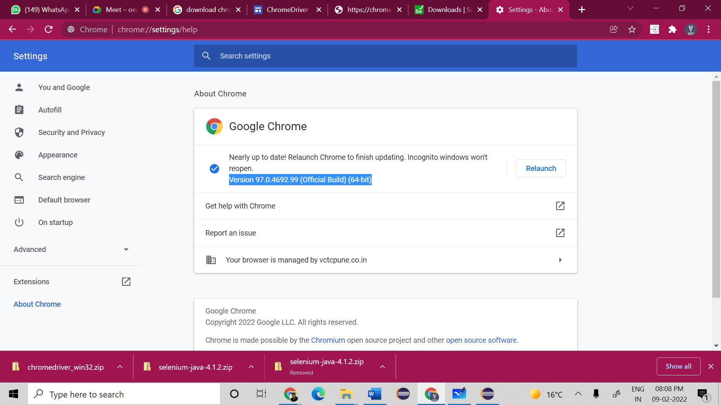

Open eclipse

Select project in eclipse🡪Right click on project and select🡪 buildpath🡪configure build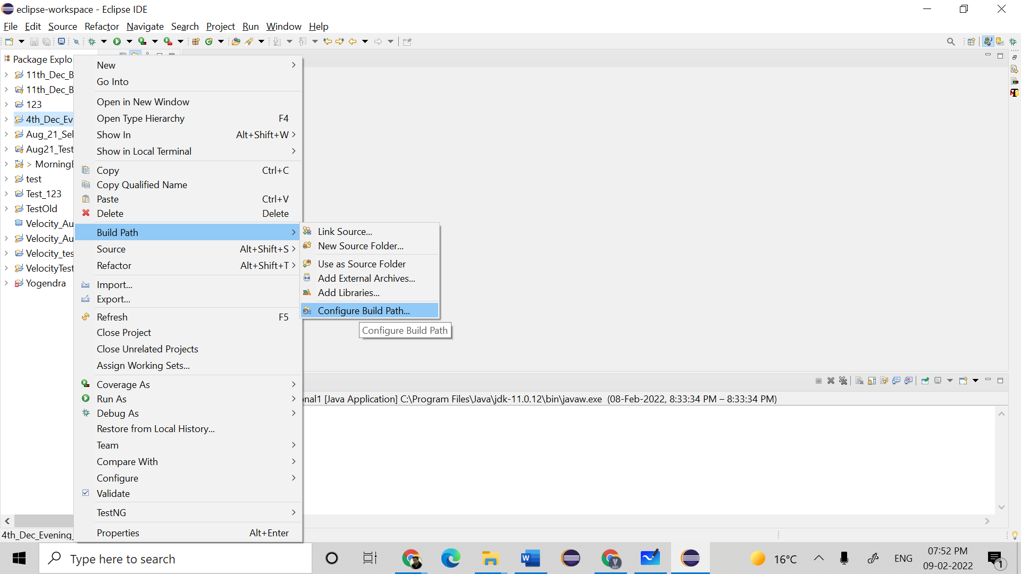

Click on libraries 🡪 class path

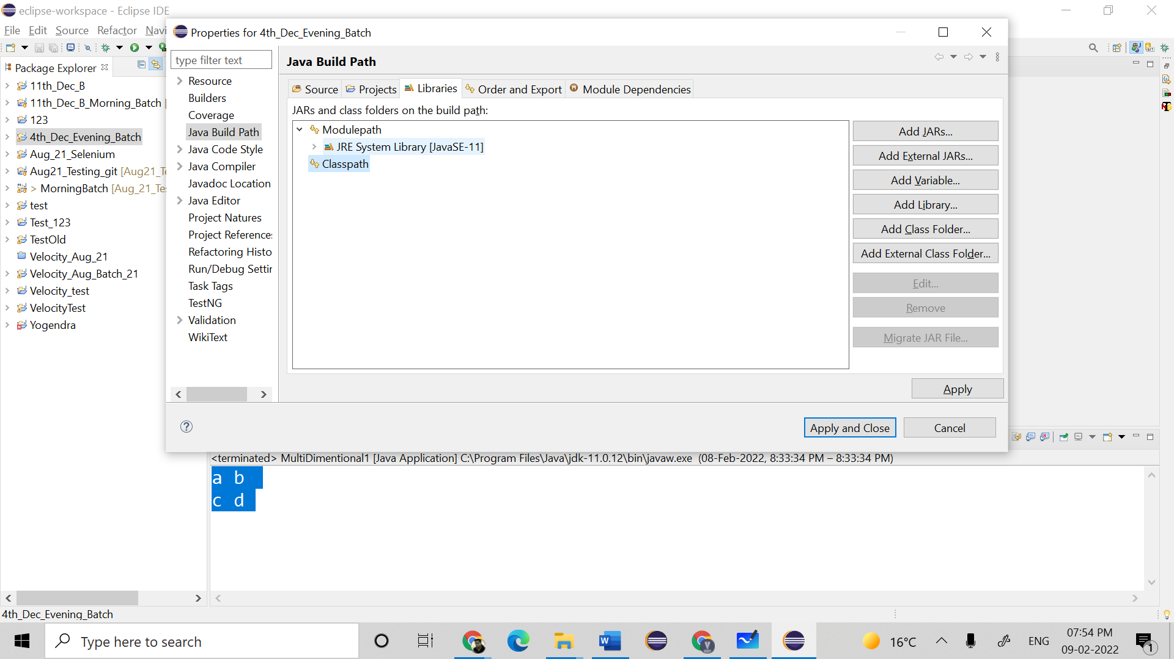

Click on add external jars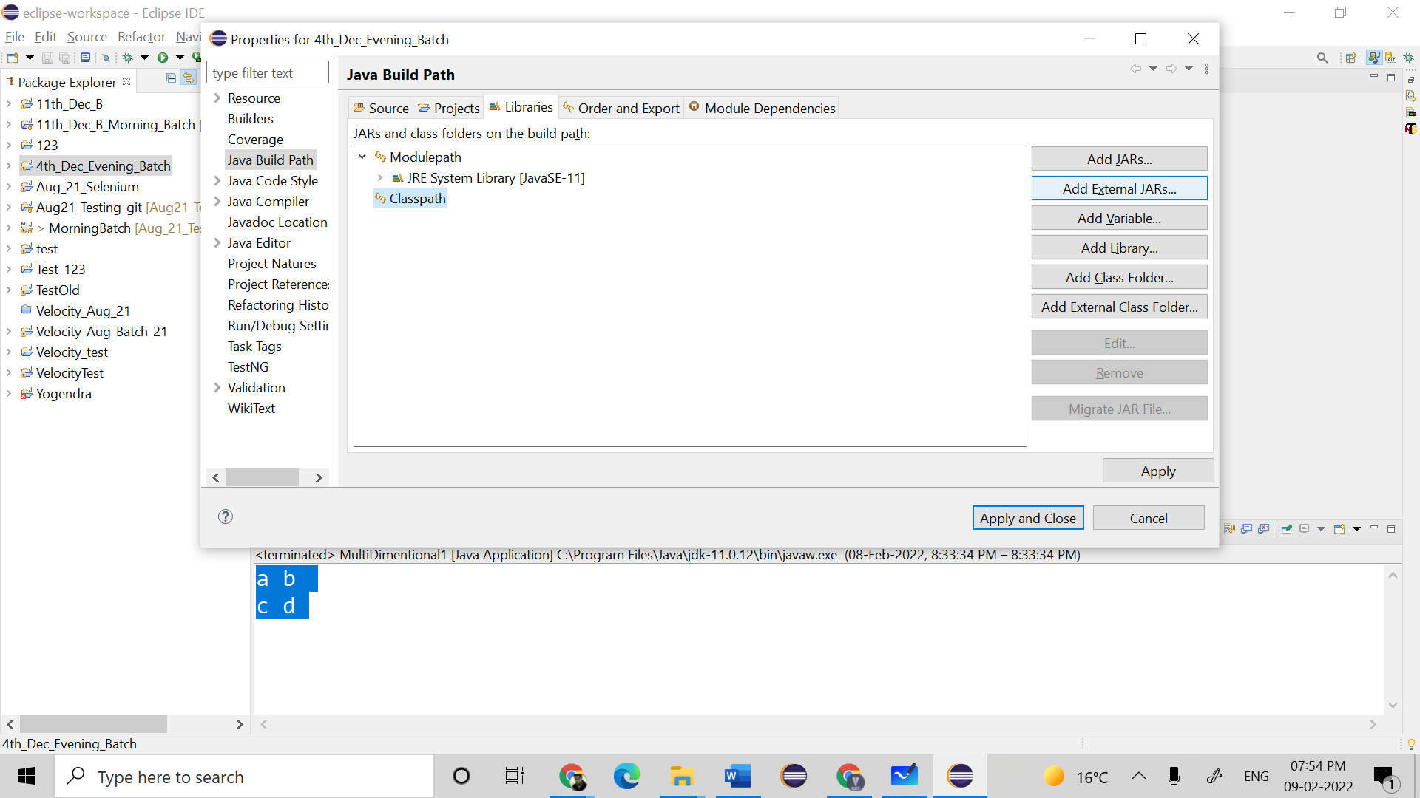

Select the folder where we kept all selenium jar files, select all jar files, click open.

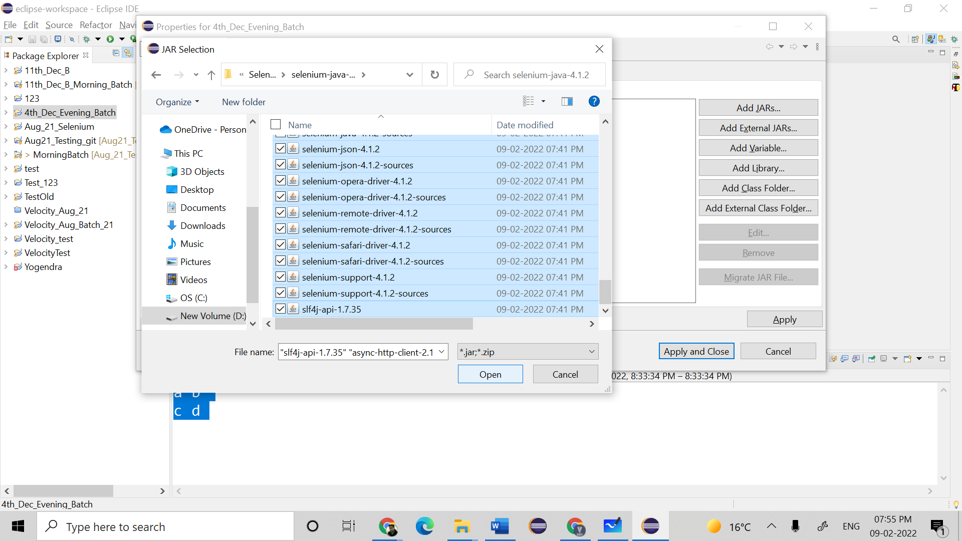

Click on apply 🡪 apply and close. Your project is ready for selenium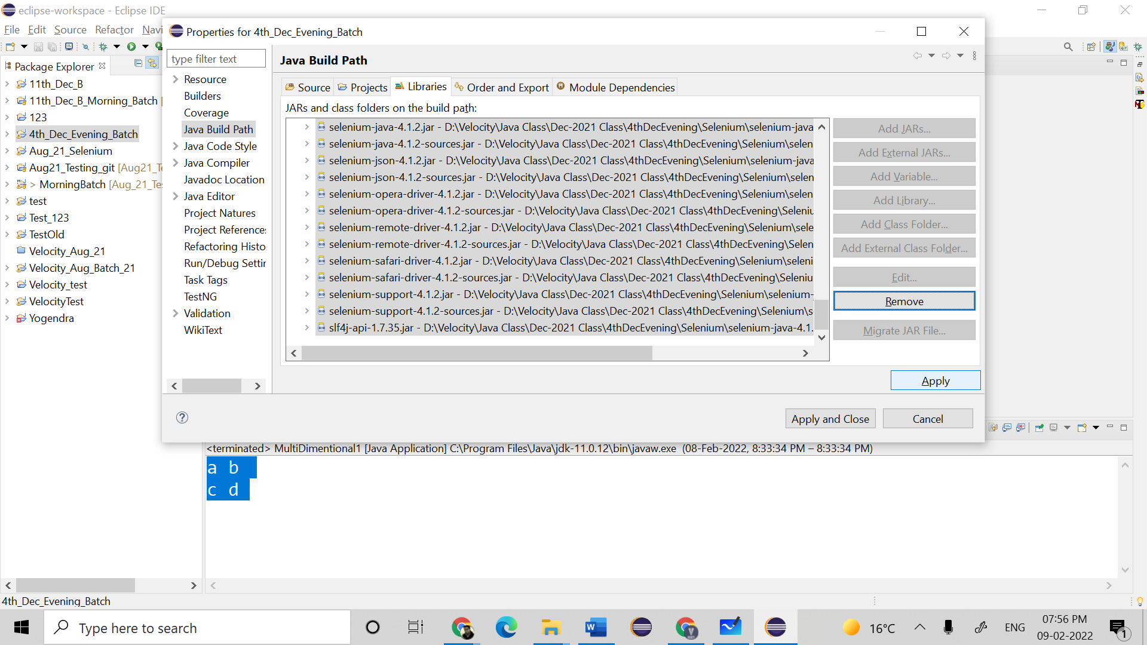

Create a package🡪 create a class(with main method)

